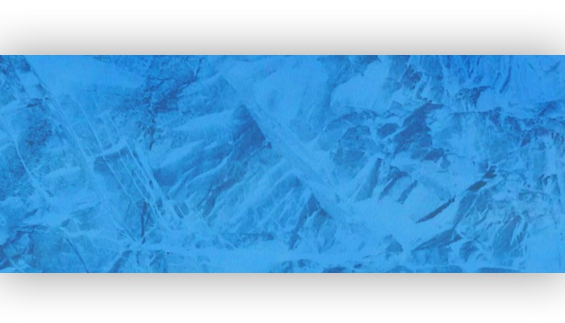
CHAD HEADLEY
(720) 418-0363
www.ChadHeadley.com
Chadleyhead@gmail.com

Professional Creative with over a dozen years of
experience in Video Productions and Photography.

PROFESSIONAL EXPERIENCE
Muscle Activation Techniques, Englewood, Colorado 2016-Present
Video Director/Editor in Marketing/Seminars Department
Worked with Marketing Department of a start-up comany to rebuild and improve the
video productions and online education.
Ran multi-cam classes using Newtek Tricaster and streamed online live to multiple cities.
Key-holder: Arrived early, unlocked doors and disarm alarm.
Managed the hiring, scheduling, and invoice/payroll for part-time contractors.

Rick Mitchell Photography Inc., Chicago, Illinois 2012-2015
Video Editor
Performed three-year video editing contract spanning multiple construction projects and educational videos
Videos include:
Wright College Math and Science Lab Renovation - Progress Record
Wright College Learning Resource Center Façade Replacement - Progress Record
Fire Alarm Systems Chicago - Educational Instructional Video
City Colleges of Chicago Preventative Electrical Maintenance Program - Educational Instructional Video
“Dear Eleanor” – Feature Film shot in Colorado, Nine Nights LLC, Los Angeles, California 2013
Picture Car Coordinator
Researched and cold-called numerous leads of possible classic car owners
Secured the availability of dozens of classic cars to be used on-camera
Maintained contacts, schedules, and logistics for each classic car required on set

US Helicopters Inc., Schaumburg, Illinois 2007-2009, 2011-2012
Aerial Photojournalist
Operated aircraft-mounted gyro camera system for WGN TV- Chicago
Worked on-call 24/7 as solo camera crew operator
Provided aerial eyewitness observations to the news desk

Creative Technologies, Schiller Park, Illinois 2010
Warehouse/Quality Control
Filled orders in the video equipment warehouse for exhibition display
Performed quality control of incoming video equipment
Executed on-site large screen display set-up
WSBT-News22, South Bend, Indiana 2005-2007
News Photojournalist
Covered breaking news, general news assignments, sporting events and investigative pieces
Operated microwave transmission live and satellite truck on breaking news locations
Pitched story ideas at daily staff meetings; engaged in writing daily assignments

WECT-TV 6, Wilmington, North Carolina 2004-2005
News Photojournalist
Shot and edited general news assignments on multiple deadlines on a daily basis
Created visually compelling award-winning photo essays for broadcast
Worked on-call status for nine consecutive months

ACME Markets, Sewell, New Jersey 1999-2004
Cashier/Over-night Stocking
Greeted customers; responded to and resolved customers’ complaints and issues
Exchanged thousands of dollars in funds for goods and items sold
Stocked and faced goods for optimal presentation

FREELANCE EXPERIENCE
Camera Operator: Studio production: JBTV, WECT, WSBT
On-location Production: Lockwood Media Group, Redface Productions,
Northwest Audio Visual Production
Video Editor: Rick Mitchell Photography, Inc.
Production Crew Member: Frequently assisted with lightning/gaffing, sound recording, sound design, cinematography, directing, on-set grip, acting and story development

EDUCATION
The Illinois Institute of Art Schaumburg, Schaumburg, Illinois
Bachelor of Fine Arts; Digital Filmmaking and Video Production, June 2012; Graduated with Honors
The Art Institute of Philadelphia, Philadelphia, Pennsylvania
Associates Degree; Video Production, September 2003; Graduated with Honors

ACCOMPLISHMENTS
Produced, shot, reported and edited a series on Hurricane Katrina relief efforts, which received the Radio and Television News Directors Association of the Carolinas Best Series in spring 2006
Member of the 2006 Associated Press-awarded Best Photo Staff in Indiana with WSBT-News22 photography staff
Won the 2001 Art Institute of Philadelphia High School Senior Scholarship Competition

SKILLS
Technical
Proficient with Tricaster Software, Adobe Premiere, Adobe Photoshop, Adobe After Effects, Adobe Illustrator, Adobe Soundbooth, Final Cut Pro 7, Soundtrack Pro, Pro Tools, Microsoft Office.
Equipment
Newtek Tricaster Mini, Projectiors and screens and running long cables, ensuring safety by taping down cables.
Worked extensively with ENG-level professional cameras, High-Definition camcorders of numerous makes and models, Owner of DSLR camera equipment, audio recording equipment, lighting/gaffing gear, etc.
Also trained in ENG Microwave live-truck set-up and operation, SAT-truck operation, and aircraft-mounted gyro-stabilized camera systems including FLIR and Cineflex.

Leadership
Management and Producing experience.
Able to make strong decisions under tight deadlines,
Attended numerous leadership workshops,
Experience in delegating assignments efficiently and fairly to team members,

Collaborative
Ample experience in producing and directing multimedia projects
Accustomed to maintaining professional conduct when working with other crew members
Exercises clear and direct communication

